Criteria A

# Problem

Karen Steinbach is currently a worker for a Sick Kids Hospital in Toronto. Currently, she is developing a brain training program for children from grades 2-5 called empower. Due to research on brain plasticity, she is creating this program to help the children whose brains aren’t functioning at their regular capacity – either due to disability, or damage. Due to the potential this program could have moving forward in the lives of these children, it is essential she uses the right resources to create the best possible activities for the children. From me, she has asked to create a two player logic game, based around a grid. It should be simple enough so that children under grade 5 may play it, and a have an easy to use graphical user interface, so that everyone playing it will be able to do so flawlessly.

The concept of Brain Plasticity is one that has really revolutionized treatment for brain damages and disabilities, and Karen is one of many who’s looking to further this treatment as soon as possible, to gain real and long lasting effects on children. Typically in treatment, children focus on word sounds, sounding out words phonetically, repeating these sounds, and constant reading. All of these activities work their brains intensively, and although boring, greatly aid the development of their brains.

The part where I come in is the actual creation of this game. The game is supposed to be an aid to the development of the children’s brains and help them practice similar skills (word skills, reading, and some math) on their journeys to success – but in a fun way. This is extremely important, not only because it gives the children something to do outside their intensive training, but also because it’s simultaneously training the brain through practice, something Norman Doidge (another researcher on Neuroplasticity) agrees is essential in the development of the brain[1].

This research is changing the lives of many more than just the children undergoing the treatment – it also impacts all their families, many teachers (now exposed to more knowledge of how the brain works and how to effectively teach), and the rest of the Sick Kids organization, as success of this program could be followed by larger scale versions of it. The other group that this impacts is all of us. Although we won’t all be taking this treatment, knowing about brain plasticity can be applied to us every single day – training ourselves towards being the best people we can be!

# Research Plan

Dr. Norman Doidge has been at the forefront of the research on neuroplasticity, and has definitely been able to address all of the currently known points about brain plasticity in his interview on the National called the “Power of Thought”. He highlights points including how our brains are able to do much more than we initially knew, including train, or specialize itself towards certain things. Our brains are also capable of much more than just specialization – they’re capable of recovery, even if it isn’t physical! This was outlined well in a book that he wrote, “The Brain’s way of Healing”, alongside more research, and even how it’s evolved to get to this amazing level of power[2]. Norman Doidge has also written another book, called “A Brain That Changes itself”, with detailing on the adaptations that the brain makes when in a situation of distress, and he even goes on to detail specific cases where neuroplasticity has saved lives and made many easier, including a woman who was able to REGAIN her sense of balance[3]! Norman Doidge goes on to state that the brain is shaped by its environment, and therefore a positive one can contribute to the success of an individual.

Further research on Neuroplasticity has revealed that there are two different types of it – early in life, it’s called developmental, or learning/memory plasticity, where the brain works on its sensory information processing and other forms of processing skills. This phase is what Karen Steinbach is targeting, as her program is for younger children. The other form occurs later in life, and helps compensate for brain damage and loss of function. Although these can both happen at any point in someone’s life, the former is happening more often as a child, and the latter as they grow up.[4]

Other research has shown that these changes aren’t permanent unless practiced and held well – for example, if you don’t do a task constantly to practice the skill you’ve developed, this change will fall off over time, just like a muscle[5]. This means that my game must have some replay value, and it can’t be “boring” after it’s been played for the first time, so that the children may develop and keep skills that they learn from it. Also, it’s important to note that this isn’t the only thing that they’re working on, so my game shouldn’t be extremely annoying or hard to play or enjoy – it should be click and play. This leaves it simple for the users of the game, and allows it to be played often, instead of once on the odd occasion (similar to Connect 4 vs. Monopoly – one’s easy and quick, the other one takes dedication)!

# Inspiration Pieces

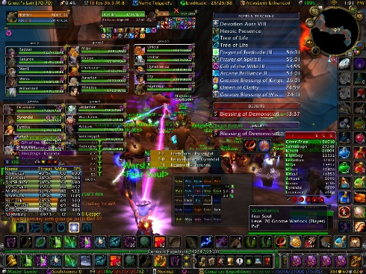**World of Warcraft[6]**

Although not a game that I’ve played myself, research into this one helps me figure out just how much bad UI that’s overwhelming can result in the downfall of a game. Many users have complained about the complexity of this game, and although not a board game like battleship, this can easily become an issue[7]. For my game, I’ll ensure that this isn’t an issue, so that any user can just pick it up and start playing. This will help fit my target group perfectly, as they’re younger and wouldn’t be well versed in complicated user interfaces. One good thing that World of Warcraft has is the amount of detail it has – every piece of it has purpose. For my game, I want to ensure that all my buttons can be easy to use, AND have significance (for battleship this may mean have a fire button instead of just a click to “lock in” the user’s choice).

An example of just how overwhelming WoW can get!

**Pogo’s Monopoly[8]**

This is Pogo (a game company)’s version of Monopoly. My favourite part about this game is the fluency, and something I’d definitely like to incorporate into my game. This is done by the game just flowing, and assuming the user knows what to do. Although not perfect in the sense that the UI is somewhat overwhelming, with everything being a button to click on, it flows a lot better without prompts. A good way to incorporate this into my game would be assuming the user knows how to play after a few turns, and removing my instructive prompts after a certain amount of turns have passed.

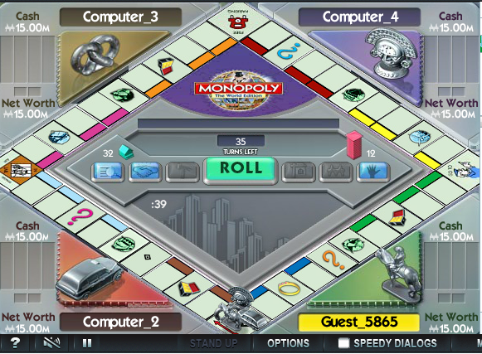

**Connect Four![9]**

Cool math games’ version of connect four is extremely simple, but after playing it, I’ve noticed a few features it lacks, and ones I’d like to add so that I may make my game better than it! The first is BAD sound effects. It’s nice that the game has sound effects, but these are not only long, they are also rather annoying! I’ll make sure that for my game, the sounds are more appealing and aren’t as often as they are in connect four. Also, I started the game by clicking on the window, which dropped a piece somewhere I didn’t want – a bad form of UI. In my game, I’ll ensure there is a better way to define a click, so that one click doesn’t seal your fate!

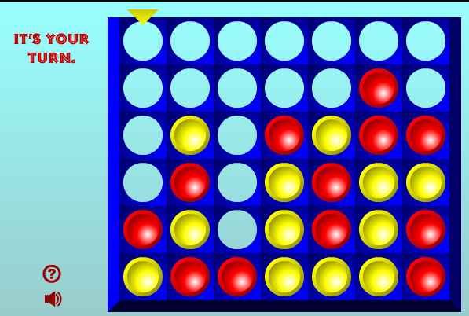

# Specifications

1. Game allows students to practice spatial, logical or linguistic skills.   
2. Game is mainly visual, with limited written content.   
3. Good user-interface design principles are used.   
4. Game is fun and engaging for grade 5 learning-disabled students.   
5. Code is easily adaptable.   
6. Requires 1 or 2 players.   
7. A new widget is used.

# Bibliography

"Dr. Norman Doidge | The Power of Thought." YouTube. Accessed January 8, 2016. [https://www.youtube.com/watch?v=2c5aTlq3nYI.](https://www.youtube.com/watch?v=2c5aTlq3nYI)

Doidge, Norman. The Brain's Way of Healing: Remarkable Discoveries and Recoveries from the Frontiers of Neuroplasticity.

Doidge, Norman. The Brain That Changes Itself: Stories of Personal Triumph from the Frontiers of Brain Science. New York: Viking, 2007.

"Neuroscience for Kids - Brain Plasticity." Neuroscience for Kids - Brain Plasticity. Accessed January 11, 2016. https://faculty.washington.edu/chudler/plast.html.

"The Brain That Changes Itself (Book Review)." Http://www.apadivisions.org. Accessed January 11, 2016. <http://www.apadivisions.org/division-39/publications/reviews/brain.aspx>.

<http://us.battle.net/wow/en/>

"I Just Bought Wow and This Is Overwhelming." World of Warcraft. Accessed January 11, 2016. http://us.battle.net/wow/en/forum/topic/3657437969.

http://www.pogo.com/games/monopoly#game

http://www.coolmath-games.com/0-connectfour

1. "Dr. Norman Doidge | The Power of Thought." YouTube. Accessed January 6, 2016. <https://www.youtube.com/watch?v=2c5aTlq3nYI>.
2. Doidge, Norman. The Brain's Way of Healing: Remarkable Discoveries and Recoveries from the Frontiers of Neuroplasticity.
3. Doidge, Norman. The Brain That Changes Itself: Stories of Personal Triumph from the Frontiers of Brain Science. New York: Viking, 2007.
4. "Neuroscience for Kids - Brain Plasticity." Neuroscience for Kids - Brain Plasticity. Accessed January 11, 2016. https://faculty.washington.edu/chudler/plast.html.
5. "The Brain That Changes Itself (Book Review)." Http://www.apadivisions.org. Accessed January 11, 2016. http://www.apadivisions.org/division-39/publications/reviews/brain.aspx.
6. http://us.battle.net/wow/en/
7. "I Just Bought Wow and This Is Overwhelming." World of Warcraft. Accessed January 11, 2016. http://us.battle.net/wow/en/forum/topic/3657437969.
8. http://www.pogo.com/games/monopoly#game
9. http://www.coolmath-games.com/0-connectfour